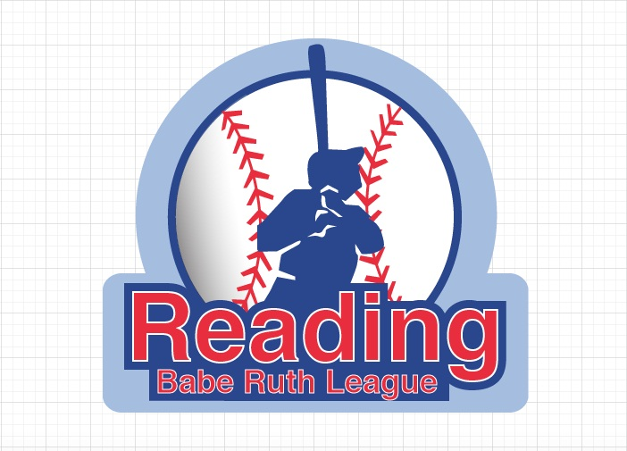

One on One Fundamentals
Registration Form
For all Babe Ruth players eligible in 2022 Spring season

Name:_________________________________________ Email:_________________________________________

Address:______________________________________________________ Age/Grade:_______________________

City:________________________________State:_______________________ Zip Code:______________________

Home Phone: ( )_________________________ Alt Phone: ( ) _______________________________

Shirt Size: ___________

Liability Release Form

I/We the parent(s)/guardian(s) of the above-mentioned minor child, hereby give my/our approval to his/her participation in the program. I/We assume all risks and hazards incidental to such participation: and I/We do hereby waive, release, absolve, indemnify and agree to hold harmless One on One Fundamentals, its organizers, sponsors, supervisors and staff for any claim arising out of an injury to my/our child to the extent covered by accident or liability insurance.

Signature:___________________________________ Date: _____________________________
(Parent/Guardian)
----------------------------------------------------------------------------------------------------------------------------------------------
Please enroll my child in the following:

2021 Fall Baseball Clinic Cost: $125.00

Saturdays - starting September 11th. (10:00 am to 12:00 pm)

Dates are: 9/11, 9/18, 9/25, 10/2, 10/16, 10/23, 10/30, 11/6, 11/13, 11/20 (weather Permitting)

Place: - Washington Park

Please make checks payable to David Gray.

Registration(s) and payment (s) are due ASAP!

Please drop off or mail to: One on One Fundamentals
c/o David Gray
29 Libby Avenue
Reading, Ma 01867

You can also pay online at www.oneononefundamentals.com

If you have any questions and/or comments, please contact David Gray at (781) 706-1136 or email coachgray15@verizon.net

