How to Register on the KC Metro Girls Lacrosse website:

- Go to www.kcgirlslax.com
- Click the GREEN “Register Now” button:
  - 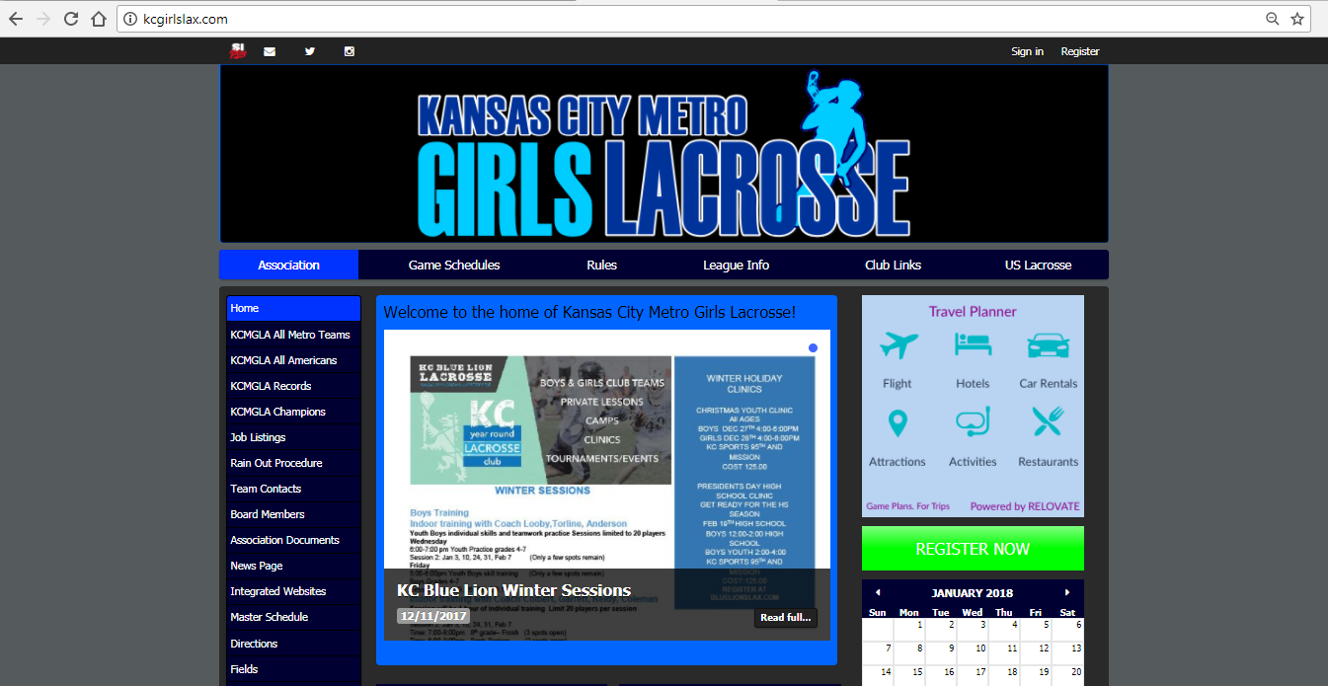

- Choose “Player” from the drop-down box:
  - 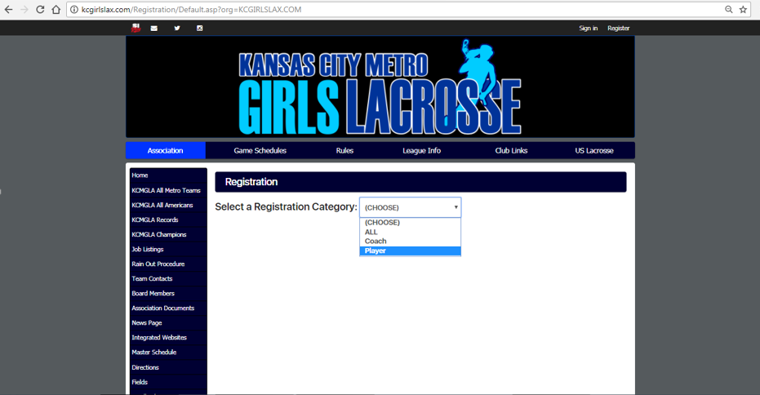

- Choose the “2018 Lees Summit West HS Player Registration” green button and follow the directions. You will need your US Lacrosse number to complete the registration.
  - If you are a returning player, use the “Sign In” option and use your login credentials that you used last season…do not create a new account.
  - If you are a new player, please create a new account.
  - Enter all required information (Name, Address, Phone #, US LAX #, etc…)
  - 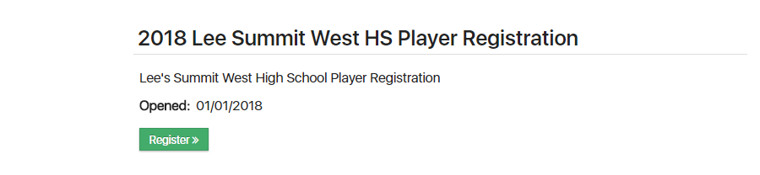

- You should be all done once you submit the information. Good luck.

